Module 1 Challenge: Crowdfunding data report

By Andrew Cheng

Abstract

Crowdfunding platforms have gained massive popularity since the late 2000s to launch new products, generate buzz and raise awareness. Despite its popularity, not all projects on platforms like Kickstarter and Indiegogo are successful. For a crowdfund to be successful, it must meet or exceed the specified goal. Here, we investigate if there are hidden trends in the success of these projects using a sample of 1000 projects.

Results

* Arts projects are more successful than other categories globally. (Fig 1)
* Arts projects tend to be more successful regardless of country. (Fig 1)
* Success rate of all categories are identical. (Supp 1)
* There is a small upward trend in number of projects in the summer and winter months (Fig 2)
* Projects whose goals are between 15,000 and 50,000 have a propensity to be more successful. (Fig 3)
* The median is a superior measure to summarize data, given high variance in number of backings. (Fig 4)
* There is more variance in the number of backers in successful projects compared to failed projects. (Fig 4)
  + **Because of the extreme right skew of the number of backers (Supp 2, 3) using the median to describe the number of backers is more accurate than the mean.**
  + **There is more variability in failed backings, which makes sense because failed projects usually have less supporters (backers) and skews the data to the left.**
* Most crowdfunding projects are less than 10,000. (Supp 4)

Limitations

* The sample size is limited.
* Social media presence, shares, and promotions can affect the success of a project *outside* these platforms.
* Some projects may fail/ be canceled because of predatory and fraudulent opportunities.
* Currencies are not normalized.

Further studies

* If the timeframe and duration of crowdfunding projects can affect the success of a project.
* If the staff picks/ spotlight affects the success of a project.

Charts

Figure 1

Figure 2

Figure 3

|  |  |  |  |  |  |  |
| --- | --- | --- | --- | --- | --- | --- |
|  | Mean backers | median backers | min backers | max backers | variance | stdev |
| Successful | 851.15 | 201.00 | 16.00 | 7295.00 | 1606216.59 | 1267.37 |
| Failed | 585.62 | 114.50 | 0.00 | 6080.00 | 924113.45 | 961.31 |

Figure 4

Supplementary figure 1

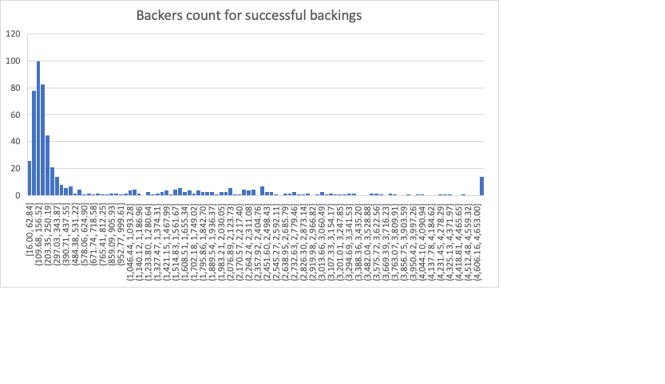

Supplementary figure 2

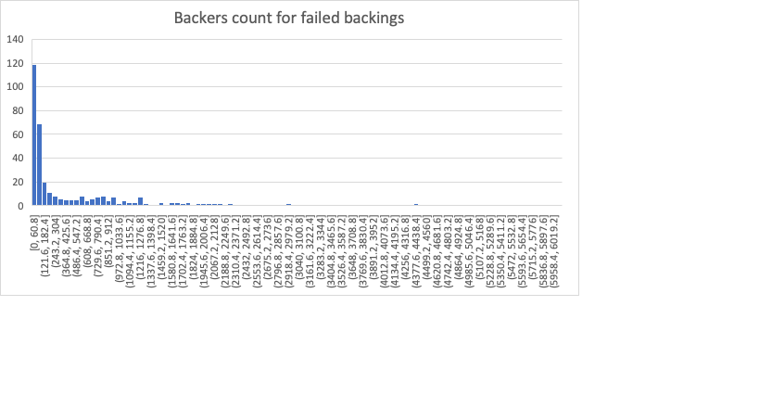

Supplementary figure 3

Supplementary figure 4